# Conference Management System

**by**

**Deena Faria**

Roll: 17102005

&

**Mahmuda Akhter**

Roll: 17102027

A project report submitted in partial fulfillment of the requirement for the degree of Bachelor of Science in Engineering in Computer Science and Engineering



Department of Computer Science and Engineering

JATIYA KABI KAZI NAZRUL ISLAM UNIVERSITY, MYMENSINGH

SUBMISSION YEAR, 2021

# Certification of Project work

The project “**Conference Management System**” by Deena Faria, Roll no: 17102005 and Mahmuda Akhter, Roll no: 17102027 has been accepted as satisfactory in partial fulfillment of the requirement for the degree of B.SC in Computer Science and Engineering.

**BOARD OF EXAMINERS**

|  |  |
| --- | --- |
| Signature |  |
| 1. Dr. Tushar Kanti Saha   Associate Professor  Dept. of CSE, JKKNIU | Supervisor |
| Signature |  |
| 1. Name of the Internal Member   Designation  Address | Member |
| Signature |  |
| 1. Name of the Internal Member   Designation  Address | Member |
| Signature |  |
| 1. Name of the External Member   Designation  Address | Member  (External) |
| Signature |  |

## CANDIDATE’S DECLARATION

We declare that this project is our own work and has not been submitted in any other form for another degree or diploma at any university of other institute of tertiary education. Information derived from the published and unpublished work of others has been acknowledged in the text and a list of references is given.

Date: 26-10-2021 Signature of the Candidates

____________________

_____________________

**Name of the Candidates**

Deena Faria

Mahmuda Akhter

## SUPERVISOR’S CONSENT FOR PROJECT/THESIS SUBMISSION

The undersigned have examined the report entitled “CONFERENCE MANAGEMENT SYSTEM” presented by Deena Faria and Mahmuda Akhter for the course CSE-400(A) and hereby, certify that it is worthy of acceptance.

Date: Signature of the Supervisor

……...……………………

Dr. Tushar Kanti Saha

# DEDICATION

We dedicated this project to our parents.

Table of Contents

List of Figures………………………………………………………………………vi-vii

Acknowledgement ……………………….................................................... ………….ix

Abstract…………………………………………………………………………….. ..viii

CHAPTER 1-INTRODUCTION……………………………………………….1

1.1-Backgrund ………………………………………………………................2

1.2-Motivation…………………………………………………………………..3

1.2-Objectives……………………………………………………….………….3

1.3-Outline………………………………………………………………………3

CHAPTER 2-ANALYSIS……………………………………………………………………4

2.1 Requirement Analysis………………………………………………………5

2.2 System Analysis…………………………………………………….……5-6

CHAPTER 3-METHDOLOGY……………………………………………….......................7

3.1 Use Case UML…………………………………………………….…………8

3.2 Data Flow Diagram(DFD)…………………………………………………8-9

3.3 System Design……………………………………………………………9-11

CHAPTER 4-IMPLEMENTATION…………………..…………………………………….12

4.1 Overview……………………………………………………………………13

4.2 Admin Login Page………………………………………………………….13

4.3 Home Page………………………………………………………………13-17

4.4 Speaker Page…………………………………………………………….17-18

4.5 Committee Page…………………………………………………………….18

4.6 TPC Members……………………………………………………………18-19

4.7 Paper Submission Page…………………………………………………19-20

4.8 Admin Section…………………………………………………………..20-25

CHAPTER 5-CONCLUSION…………………..……..……………………………………26

5.1 Future Direction……..……………………………………………………..27

5.2 Discussion………………………………………………………………….27

References…………………………………………………………………………………..28

# List of Figures

Fig.3.1: Use case UML for conference management system……………………………….8

Fig.3.2: Data Flow Diagram for conference management system……….…………………9

Fig.3.3: Flowchart of the admin login system…………………….……..…………………10

Fig.3.4: Workflow of Admin Panel……………………………….…..……………………11

Fig.3.5: Workflow of User part…………………………………………………………….11

Fig.4.1: Administrator Login………………………………………………………………13

Fig.4.3.1: Conference Topics………………………………………………………………14

Fig.4.3.2: Publications……………………………………………………………………..14

Fig.4.3.3: Call for Paper……………………………………………………………………15

Fig.4.3.4: Important dates…………………………………………………………………..15

Fig.4.3.5: Conference Schedule…………………………………………………………….16

Fig.4.3.6: Submission guidelines…………………………………………………………..16

Fig. 4.3.7: Sponsors and Contact information……………………………………………..17

Fig.4.3.8: Keynote and Technical Sessions………………………………………………..17

Fig.4.4: Keynote Speakers……………………………………………………..………….18

Fig.4.5: Committees Page………………………………………………………..………..18

Fig.4.6: TPC Members Page………………………………………………………………19

Fig.4.7.1: User login page for submitting paper…………………………………………..19

Fig.4.7.2: User can upload their papers……………………………………………………19

Fig.4.7.3: User can view and download their papers………………………………………20

Fig.4.8.1: Admin can add new conference topic………………………….………………..20

Fig.4.8.2: Admin can add new conference date…………………………..………………..20

Fig.4.8.3: Admin can add new events…………………………………….………………..21

Fig.4.8.4: Admin can add committees……………………………………..……………….22

Fig.4.8.5: Admin can speakers’ name, topic and designation …………………………….22

Fig.4.8.6: Admin can add TPC Members………………………………………………….23

Fig.4.8.7: Publications detail add page…………………………………………………….23

Fig.4.8.8: Submission guidelines addition page..………………………………………….24

Fig.4.8.9: Sponsors addition page..………………………………………………………..24

Fig.4.8.10: Details about the conference addition page..………………………………….25

Fig.4.8.11: Keynote and technical sessions addition page..……………………………….25

# Abstract

This project report deals with the conference management system which is held to share new idea and knowledge about some special topics. Scientists, researchers, and professionals are required to check all the conferences related to their works which are already held or going to be held soon in different parts of the world to attend the conference to gain knowledge from the conferences. Administrator will add the details about the various conferences available to their beneficiary. Using a conference management system, users can enter into the system by giving the username and password to submit their paper. Users can submit their papers for conference and receive a feedback about their papers. Our system supports every aspect of the conference organization process. This includes conference declaration and scheduling, paper submission, registration handling of the conference participants, searching, downloading papers, management of multiple conferences at a time. We believe that this system will be applicable to manage any scientific/technical conference.

**Acknowledgement**

A project is a golden opportunity for learning and self-development. We consider ourselves very lucky and honored to have so many wonderful people lead us through in completion of this project.

Our grateful thanks to **Dr. Tushar Kanti Saha** who in spite of being extraordinarily busy with his duties, took time out to hear, guide and keep us on the correct path. We do not know where we would have been without him.

**Dr. Mst. Jannatul Ferdous,** Head of the Department monitored our progress and arranged all facilities to make life easier. We choose this moment to acknowledge her contribution gratefully.

We would like to thank **Project Selection Committee** for efforts and help provided to us to get such an excellent opportunity.

Last but not the least there were so many who shared valuable information that helped in the successful completion of this project.

|  |  |
| --- | --- |
|  | Chapter 1 ☑**Introduction** |

|  |  |
| --- | --- |
|  | ☑Topics   * 1.1 Background * 1.2 Motivation * 1.3 Objectives * 1.4 Outline |

* **1.1 Background**

A conference is a meeting of people who "confer" about a topic. [1]

A conference is generally understood as a meeting of several people to discuss a particular topic. It is often confused with a convention, colloquia or symposium. While a conference differs from the others in terms of size and purpose, the term can be used to cover the general concept. A convention is larger than a conference; it is a gathering of delegates representing several groups.

At a conference, innovative ideas are thrown about and new information is exchanged among experts. Its purpose could be one of the following:

An **academic conference** is a gathering of scientists or academicians, where research findings are presented or a workshop is conducted.

A **business conference** is held for people working in the same company or industry. They come together to discuss new trends and opportunities pertaining to the business

A **trade conference** takes place on a larger scale. Besides businessmen, there are members of the public who come to network with vendors and made new connections. Such a conference consists of workshops and white paper presentations.

An **unconference** differs from the traditional conference, since it avoids the high costs, top-down organizational hierarchy and sponsored presentations. All attendees are equally knowledgeable about the topic and the discussion follows an open mode; usually without a single speaker addressing the gathering.

Most conferences have one or more keynote speakers who will deliver the keynote speech. These are common at academic and business conferences. The speakers chosen are eminent personalities in the related field and their presence is meant to attract more people to attend the conference. There are various types of conferences:

A **symposium** is a casual gathering and includes refreshments and entertainment.

A **seminar** is organized to discuss a particular topic. They are usually educational in nature and attendees are expected to gain new knowledge or skills at the end of the seminar.

A **workshop** is more of a hands-on experience for the participants with demonstrations and activities; the amount of time one speaker addresses the group is limited.

A **round-table** conference is a get-together of peers to exchange thoughts and opinions on a certain topic, usually political or commercial. There are a limited number of participants who sit at a round table, so that each one can face all the others.[2]

* **1.2 Motivation**

The motivation behind the development of conference management system is to manage a conference easily and autonomously. Taking into consideration the time and human resources necessary, in order to reduce them the idea to translate these tasks into a virtual and compact system appeared. Studying the systems for conference management that are available on the market at the current moment, it has been noticed that these systems cover the process for management, offers support for multiple users and some for a conference schedule.

* **1.3 Objectives**

Our main objective is to develop a web-based software that-

* supports the organization of conferences especially scientific conferences.
* helps the program chair(s), the conference organizers, the authors and the reviewers in their respective activities.
* includes information about program committee chair, program committee members (reviewers), general chair, publicity chair, and authors.
* process of conference organization consisting of many phases, such as call for papers, paper submission, paper review, review discussion, paper re-submission, and author notification.
* Manage conference sessions’ schedules.
* **1.4 Outline**

The project report has five chapters in total. The first chapter describes the idea about our project “Conference management System”. The second chapter has given the overview of requirement analysis and system analysis. In third chapter, there is description of the methodology and design of the project. The fourth chapter shows the implementation i.e., output of the system. The fifth chapter includes future direction and discussion. Here we concluded the report. Then we provided the references for information that we used in this report. As it is a progress report, we just discussed about those things which we did so far.

|  |  |
| --- | --- |
|  | Chapter 2 ☑**Analysis** |

|  |  |
| --- | --- |
|  | ☑Topics   * 2.1 Requirement Analysis * 2.2 System Analysis |

* **2.1 Requirement Analysis**

**Functional Requirements:**

Following functions will be performed by the system:

* **Home**- briefly describes the whole system
* **Speakers**- contains names and designations of all speakers
* **Committees-**contains all committees names and their members
* **Call for Papers-** ask people to submit original, scholarly articles for review and consideration for publication
* **Important Dates-** contains all dates for paper submission, conference etc.
* **Schedules-** contains event schedules
* **Submission Guidelines-** contains guidelines for submission and registration
* **Venue-** show the location of events

**Non-Functional Requirements:**

* **Security**- System will provide safety for users’ personal information
* **Login system-** Systemwill provide a login system for users
* **Registration System-** A registration system will be provided
* **Performance**- Loading time for the website will be minimized
* **Storage**- Storage size will be minimum

**2.2 System Analysis**

External Interface Requirement:

* **User Interfaces -** User interface will be provided through a web browser as a web site.
* **Hardware Interfaces** - 256MB RAM, 800 MHz Intel, Pentium or AMD processor, keyboard, mouse.
* **Software Interfaces** - System will be provided through a web browser

This project is the web-based application. The project background model specially designed on the basis of certain web programming language like PHP, MYSQL, JAVASCRIPT, CSS, and HTML etc.

## Hardware Support

|  |  |
| --- | --- |
| Computer | PC-AT |
| Processor | INTEL P3-above |
| Processor Speed | 250 MHz to 833MHz |
| RAM | 128MB above |
| Hard Disk | 2GB to 30 GB |
| Input Device | Keyboard, Mouse |
| Output Device | VDU |

## Programming Language

|  |  |
| --- | --- |
| Tools | Notepad++ |
| Front end | PHP, JAVASCRIPT, CSS, HTML |
| Database | MYSQL |
| Webserver | Apache |

## Software Support

|  |  |
| --- | --- |
| Operating System | Windows XP, Windows VISTA, LINUX, Windows 10 |
| Web Server | Apache Tomcat, Macromedia JRun, Jetty |

|  |  |
| --- | --- |
|  | Chapter 3 ☑**Methodology** |

|  |  |
| --- | --- |
|  | ☑Topics   * 3.1 Use Case UML * 3.2 Data Flow Diagram (DFD) * 3.3 System Design |

* **3.1 Use Case UML**

This figure shows the use case diagram for the system. It shows the representation of a user’s interaction with our system. It also shows the functionality of all subsystem of this project.

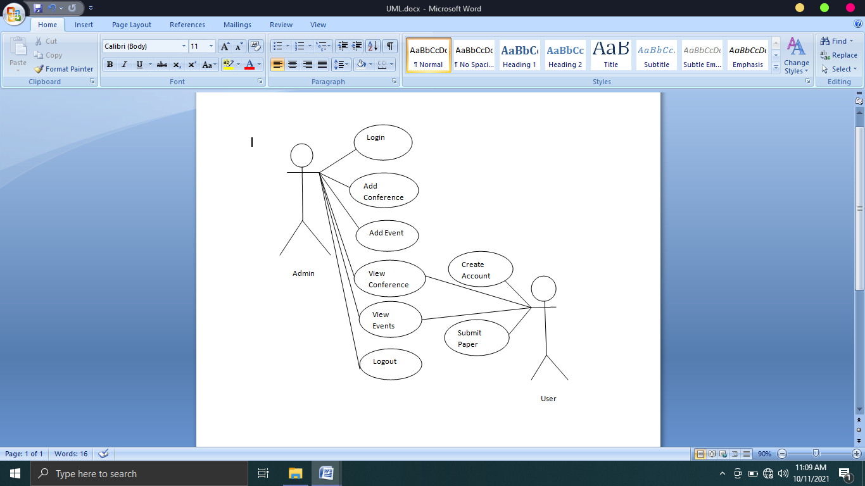

Fig.3.1: Use case UML for conference management system

* **3.2 Data Flow Diagram (DFD)**

This figure shows the data-flow diagram of the system. It shows information about the outputs and inputs and data stores of each entity of the system. It also shows how the information flows through the system.

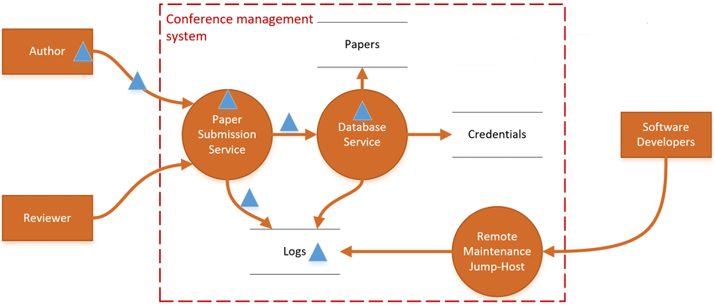

Fig.3.2: Data Flow Diagram for conference management system

**3.3 System Design**

System design is most creative and challenging task. The system design document describes the system requirements, operating environment, system and subsystem architecture, files and database design, input formats, output layouts, human-machine interfaces, detailed design, processing logic, and external interfaces.

# Proposed System Design

## 3.3.1 Admin Panel Design

Admin can maintain this website by supporting login facility. It is also fully secured page. Without appropriate email and password, it cannot be accessed by anyone. Only admin can access this page. In this case if email or password is not matched with database then invalid user name and password massage is shown.

True

No

Yes

False

Invalid username or password

Logout?

If username=”$username” and Password=”$password”

Admin Login

Admin Home

Login Home Page

Fig.3.3: Flowchart of the admin login system

Admin can add topics to the conference and manage user. Admin can also be able to view the user information.

**Admin Panel**

* Manage Conference
* Add Conference Topics, Date and Location
* Manage Conference Schedule
* Add Submission Guidelines
* View Conference
* Manage Sponsors
* Edit/Delete Conference

Fig.3.4: Workflow of admin panel

## 3.3.2 User Part Design

Users can view conference topic, schedule, call for paper information etc. They can submit paper by registering in the system with the help of submission guidelines. They can also see speakers, committees’ and TPC members’ information for the conference being held. They can also watch the speech delivered by the speakers.

USER

View Conference Schedule

Call for Paper

Submit Paper

Publications

About Conference

Home

Fig.3.5: Workflow of user part

|  |  |
| --- | --- |
|  | Chapter 4 ☑**Implementation** |

|  |  |
| --- | --- |
|  | ☑Topics   * 4.1 Overview * 4.2 Admin Login Page * 4.3 Home Page * 4.4 Speaker Page * 4.5 Committee Page * 4.6 TPC Members * 4.7 Paper Submission Page * 4.8 Admin Section |

* **4.1 Overview**

The implementation phase is a operational phase of our system. This phase is where we start to written program code for the development of the system. We follow the requirements specification from the design stage and start to create the new system. The Implementation Phase features a key step in the project system construction. The previous phases lay the foundation for system development; the following phases ensure that the product functions as required.

* **4.2 Admin Login Page**

Admin can login with his/her username and password. If both information matches with the stored information in the database then login will be successful, otherwise it will show invalid username or password.

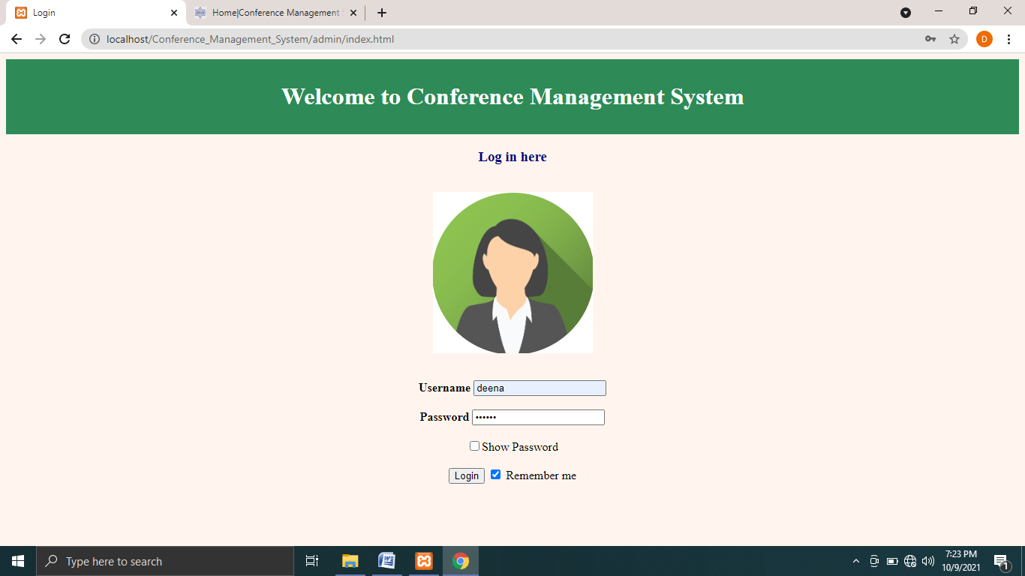

Fig.4.1: Administrator login

* **4.3 Home Page**

When user enters into the system, he/she will view the homepage that contains conference topics, call for paper, important dates, conference schedule, submission guidelines, sponsors and contact information.

In conference topics section, user can see the name, short name, date and location of the conference.

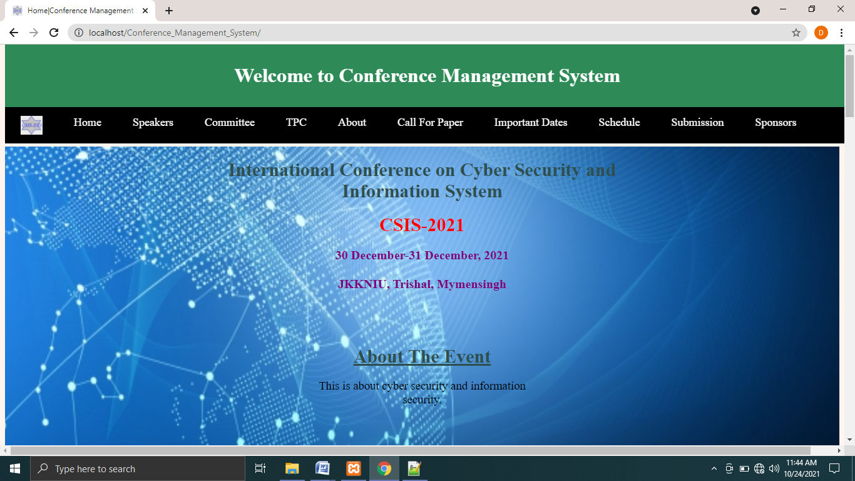

Fig.4.3.1: Conference topic

In publications section, users can see the publications details.

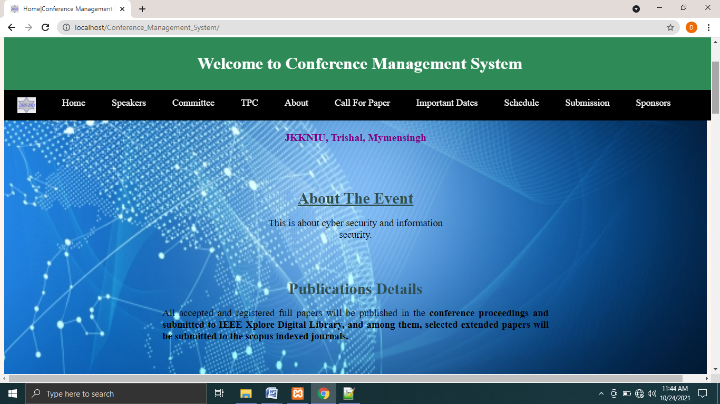

Fig.4.3.2: Publications

In call for paper section, user can view and download the paper called for conference

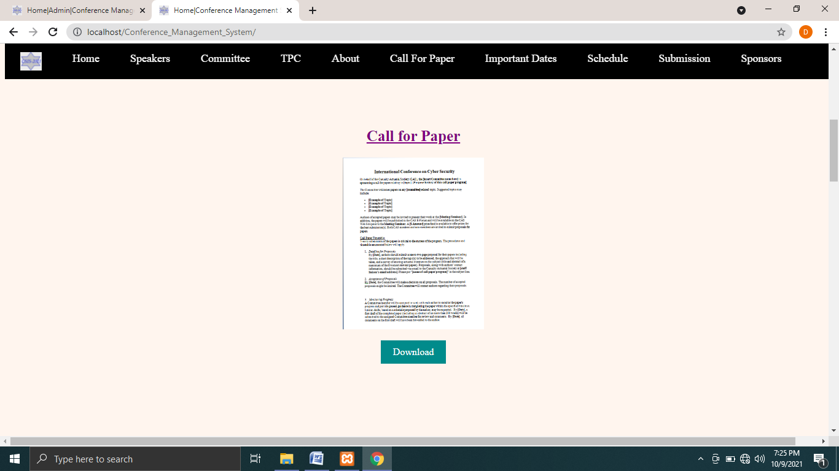

Fig.4.3.3: Call for Paper

In important date section, date of paper submission, conference date etc. are shown.

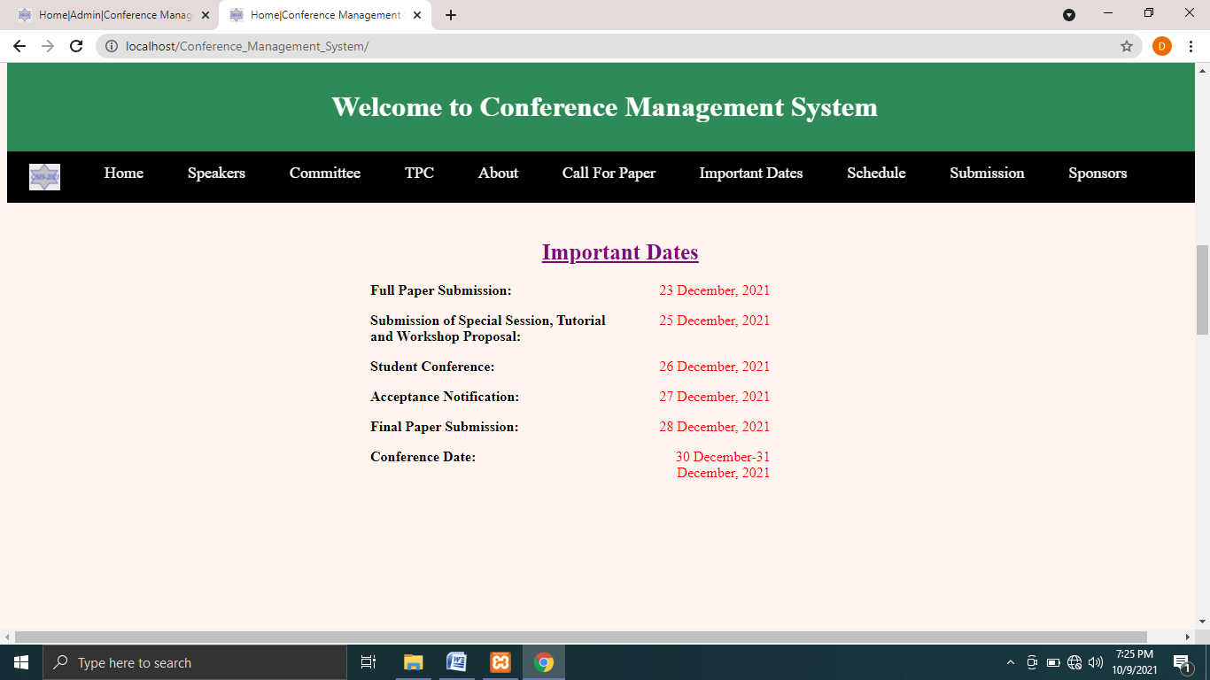

Fig.4.3.4: Important dates

In conference schedule section, name of the event and their start time and end time are shown.

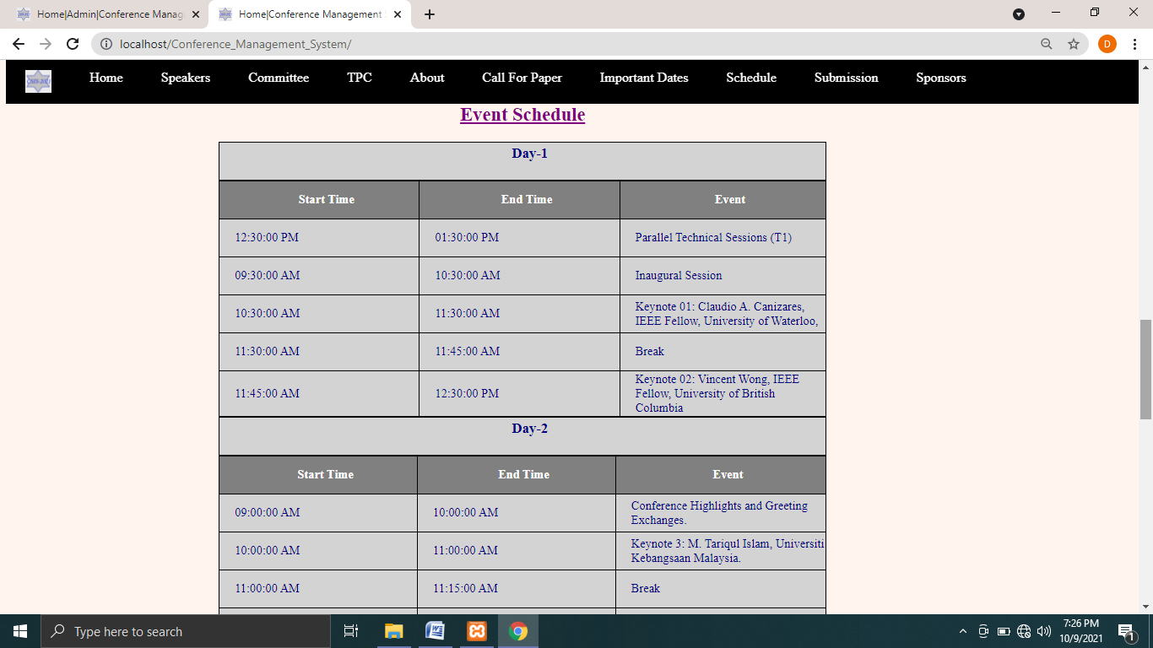

Fig.4.3.5: Conference Schedule

In submission guidelines section, guidelines for paper submission are given.

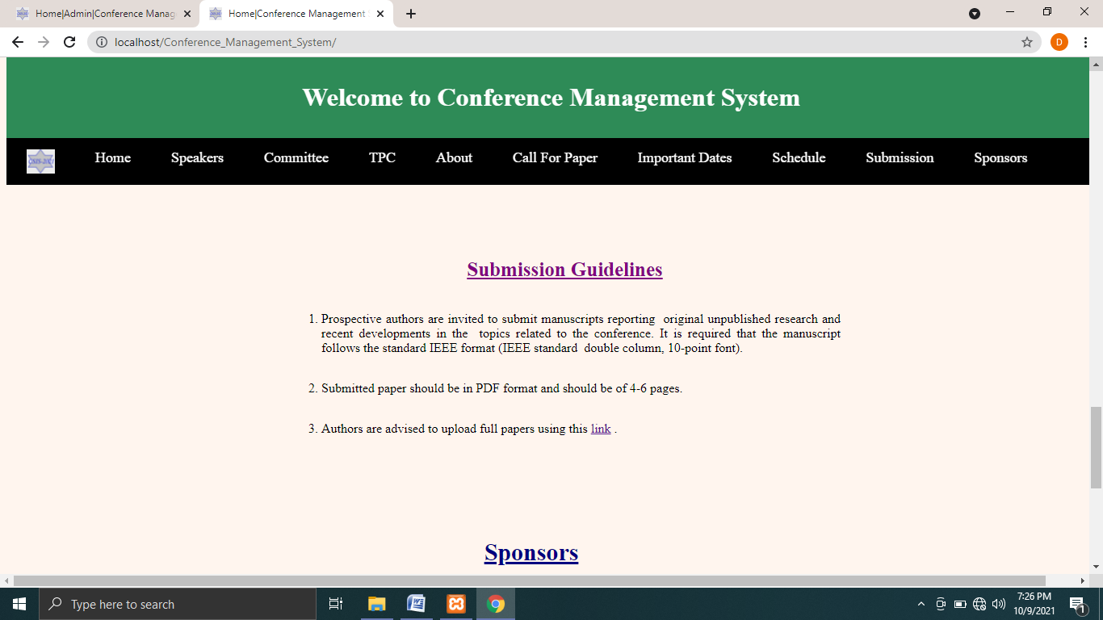

Fig.4.3.6: Submission guidelines

In sponsors section, users can see sponsors for the conference. In the contact us section, users can see contact information like mobile numbers, email addresses etc.

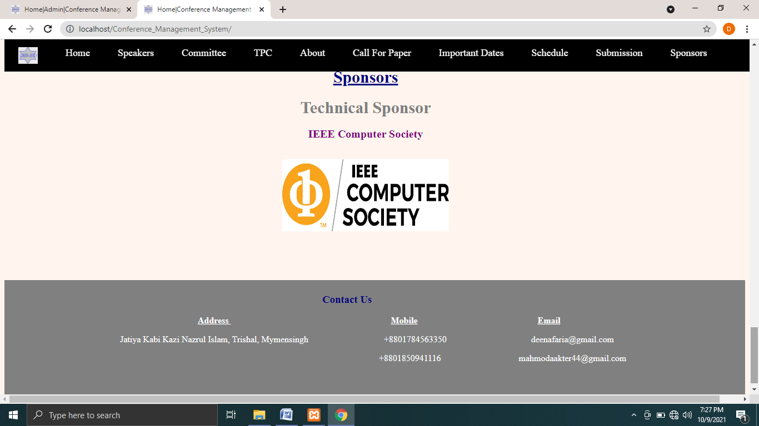

Fig. 4.3.7: Sponsors and Contact information

In keynote and technical sessions, user can see which keynote topic will be discussed when and in which room. Users also can see parallel technical sessions and the name of the keynote speakers.

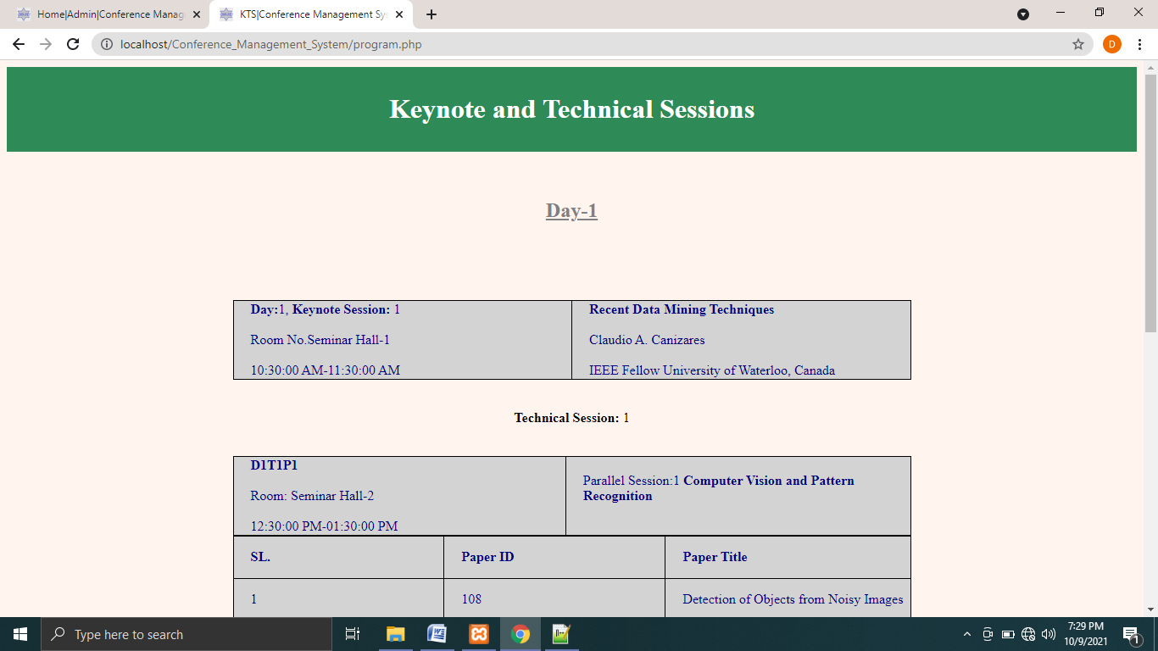

Fig.4.3.8: Keynote and Technical Sessions

**4.4 Speaker Page**

In keynote speakers section, users can see the keynote topic to be discussed and the name and designation of the speakers. If available, videos of the speech can also be viewed.

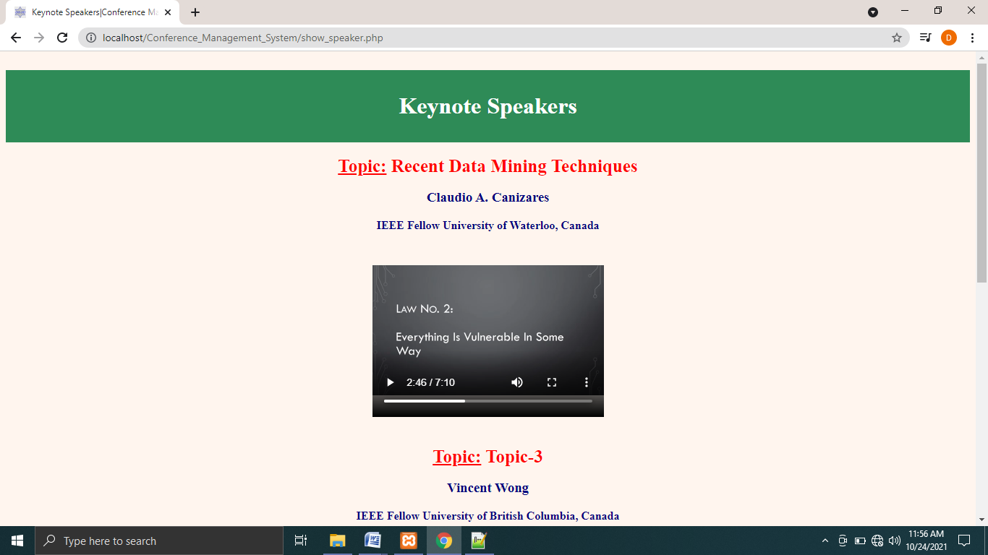

Fig.4.4: Keynote Speakers

**4.5 Committee Page**

In committee page, users can see the committees formed for the conference like patron, chief patron etc.

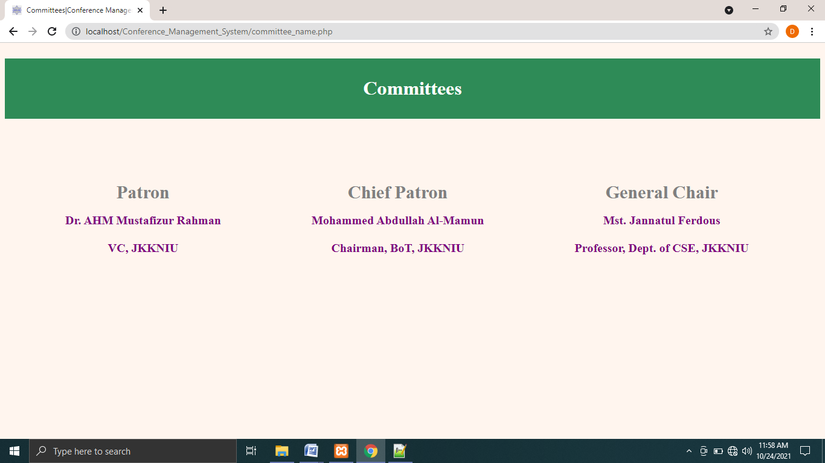

Fig.4.5: Committees Page

**4.6 TPC Members**

In TPC page, users can see technical program committee members.

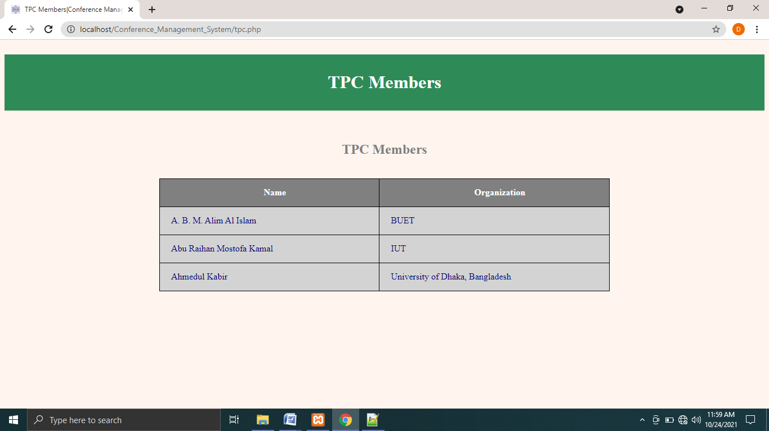

Fig.4.6: TPC Members Page

**4.7 Paper Submission Page**

Users can login to submit their paper using the link provided in the submission guidelines section. If they do not have any account, they can simply register there. Then they can upload their papers there and view them.

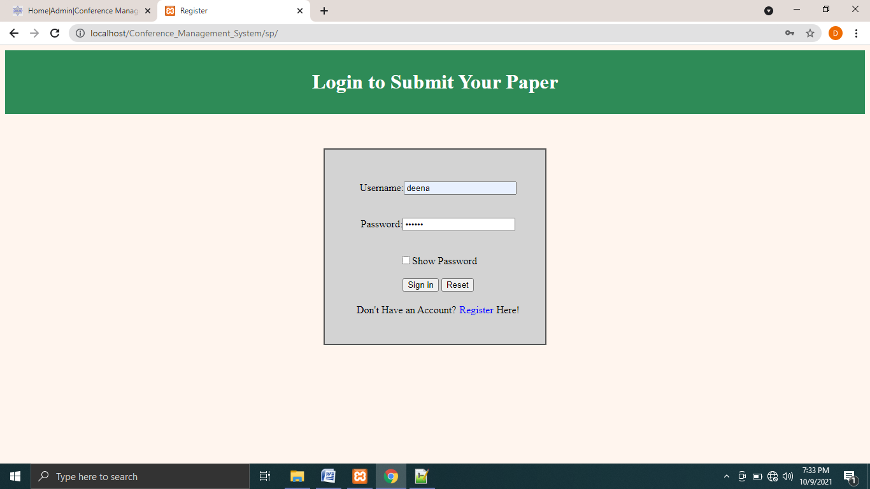

Fig.4.7.1: User login page for submitting paper

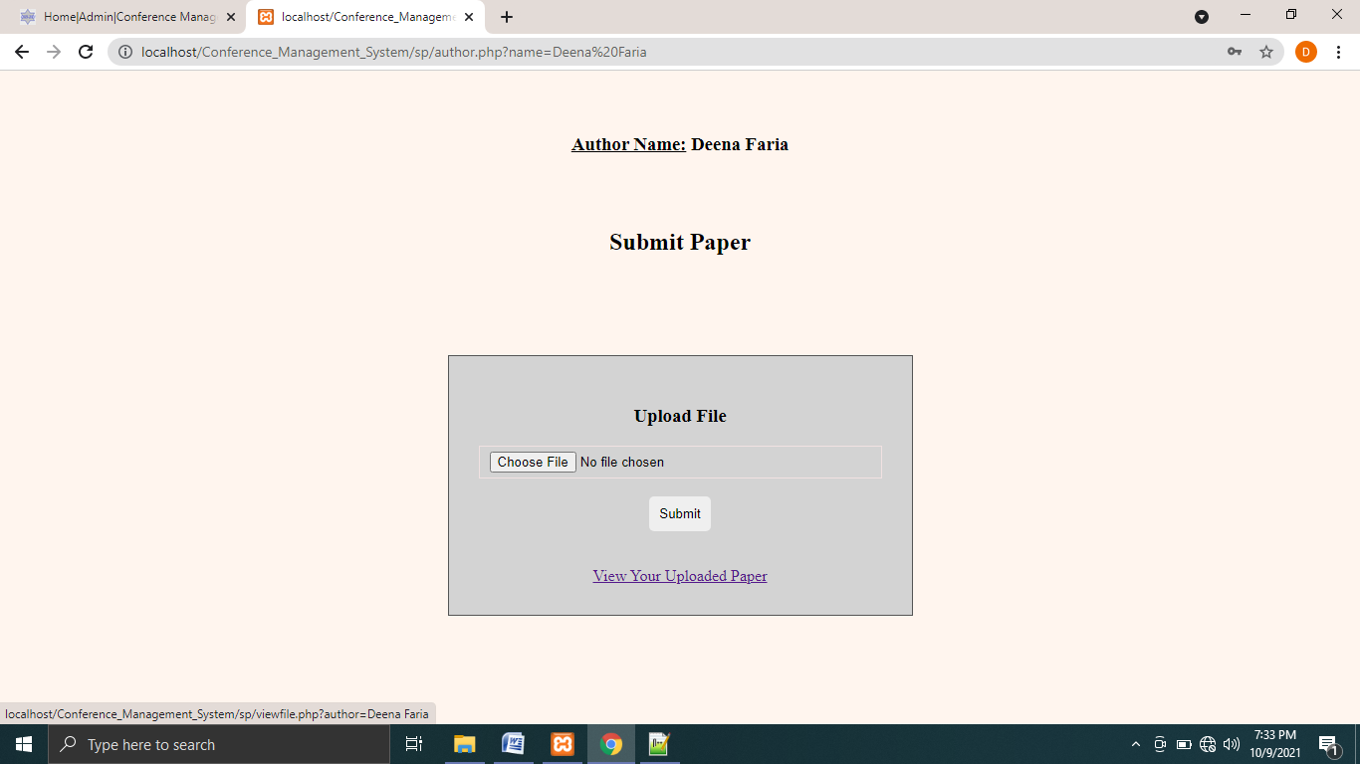

Fig.4.7.2: User can upload their papers

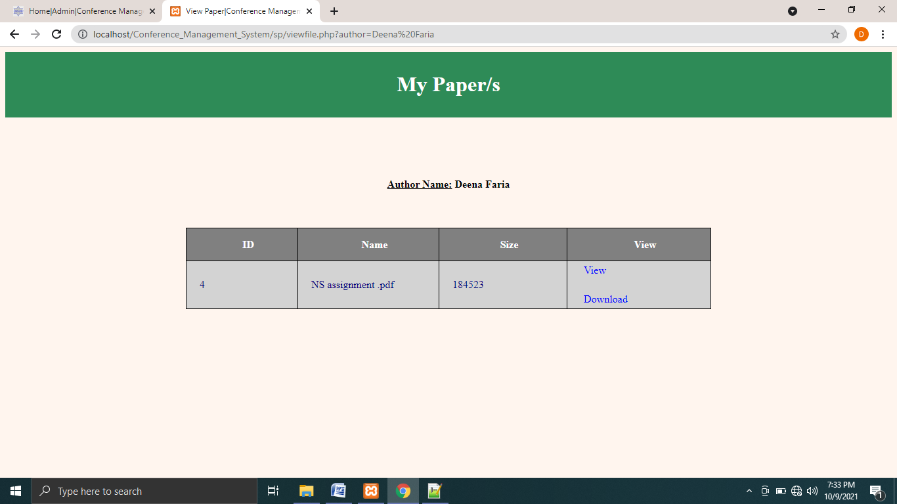

Fig.4.7.3: User can view and download their papers

**4.8 Admin Section**

In the admin section, admin will be provided with a form where he/she can add the name of the conference, date and location of the conference, conference dates and can add various events to the conference.

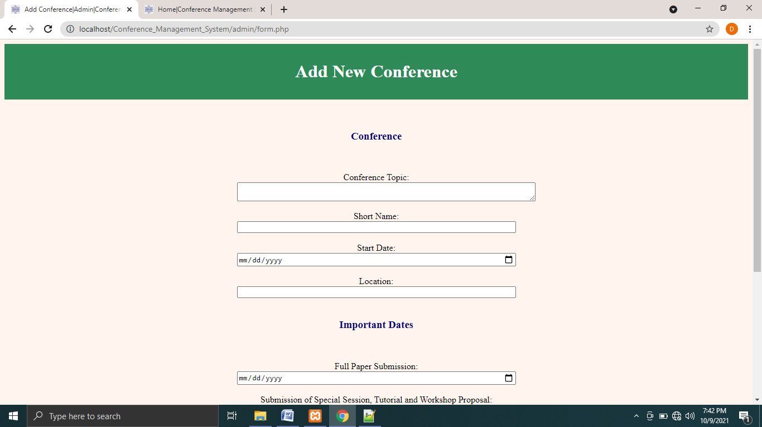

Fig.4.8.1: Admin can add new conference topic

Admin can add the date of paper submission, conference etc.

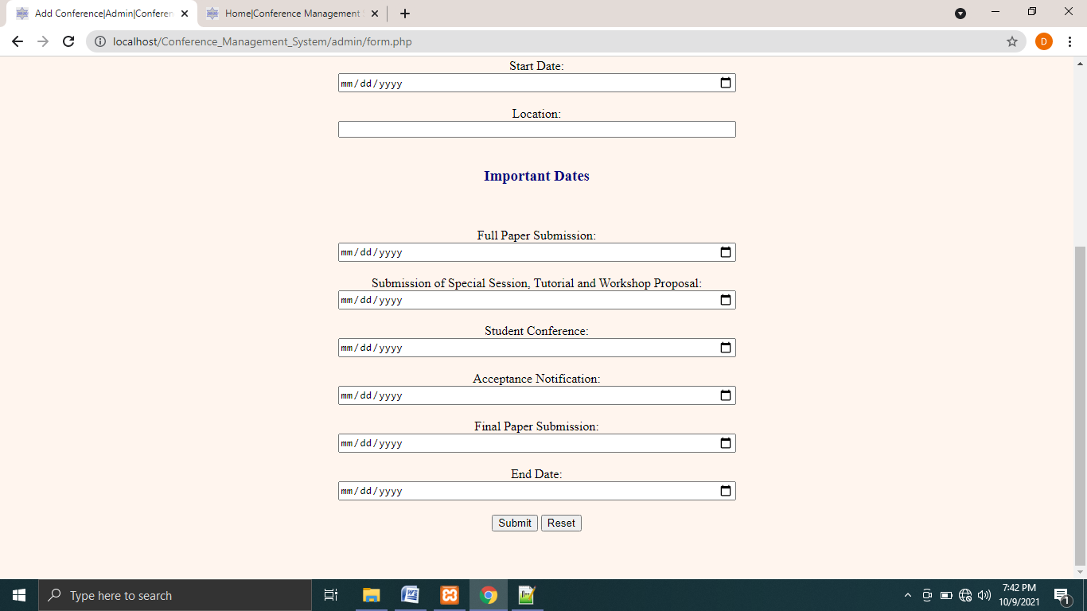

Fig.4.8.2: Admin can add new conference date

Admin can add the name of event and their start and end time.

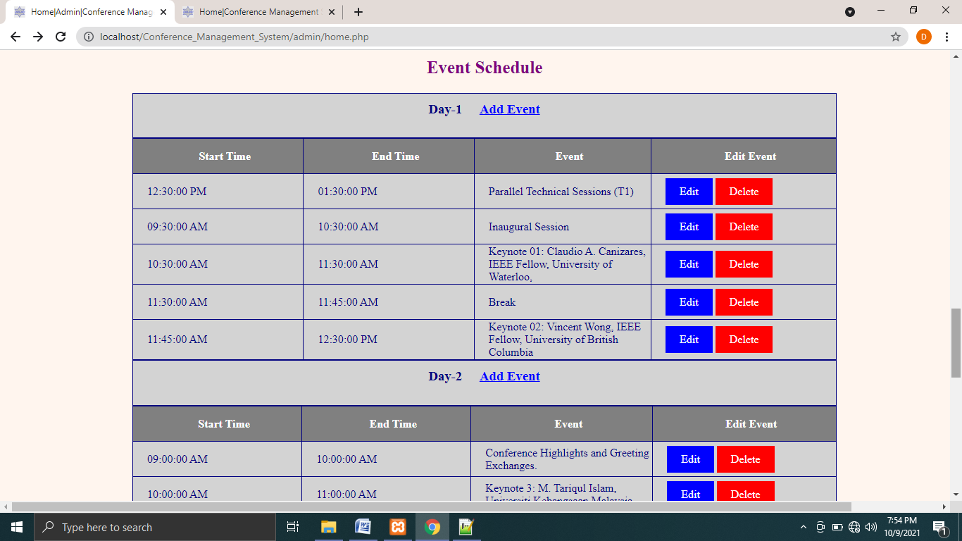

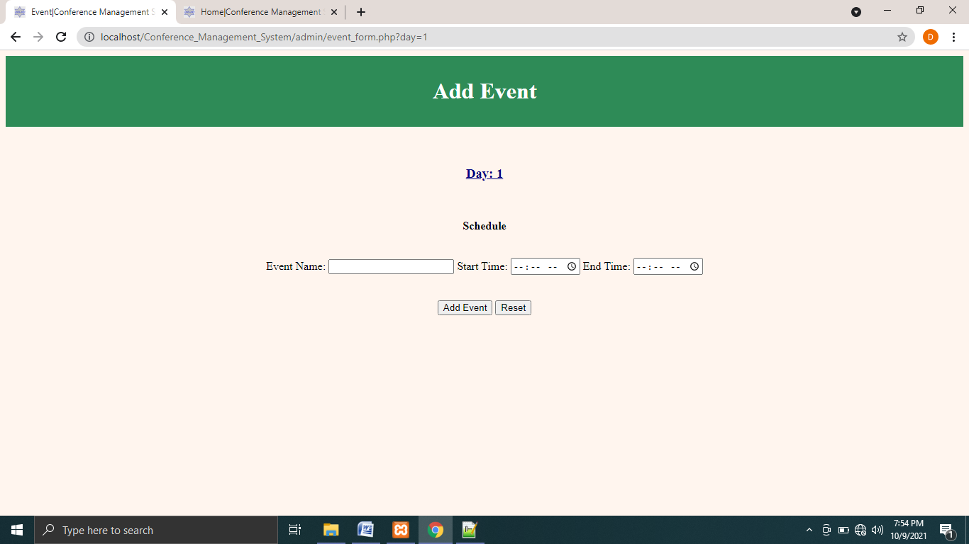

Fig.4.8.3: Admin can add new events

Admin can add speakers, committees and tpc members in respective forms. They can also edit or delete them as they wish.

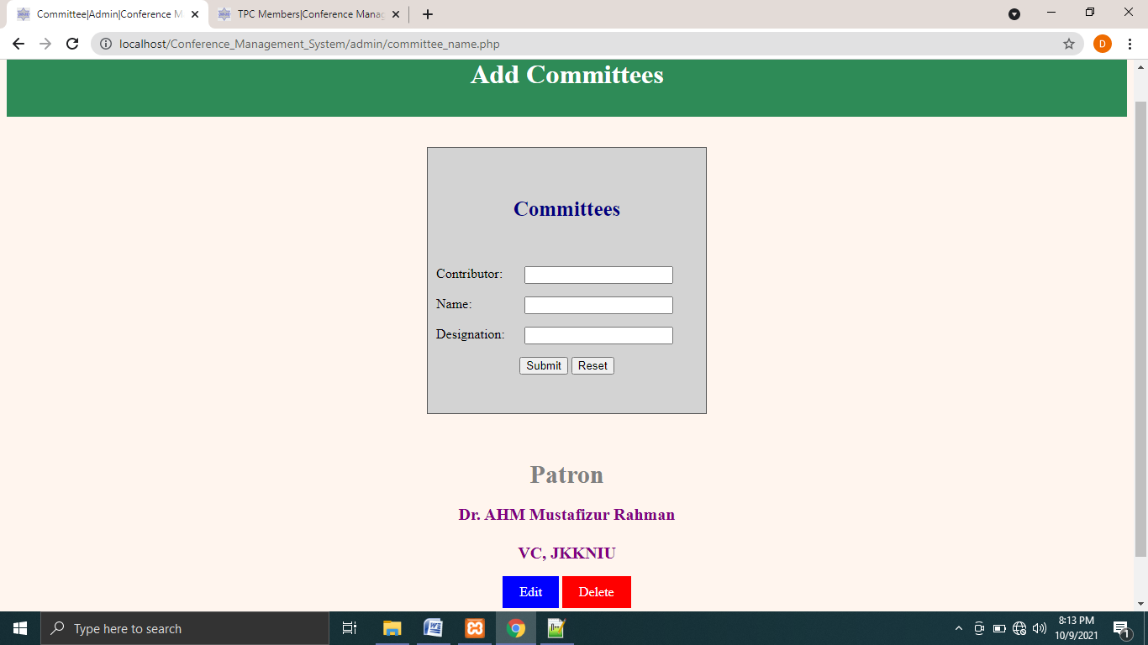

Fig.4.8.4: Admin can add committees

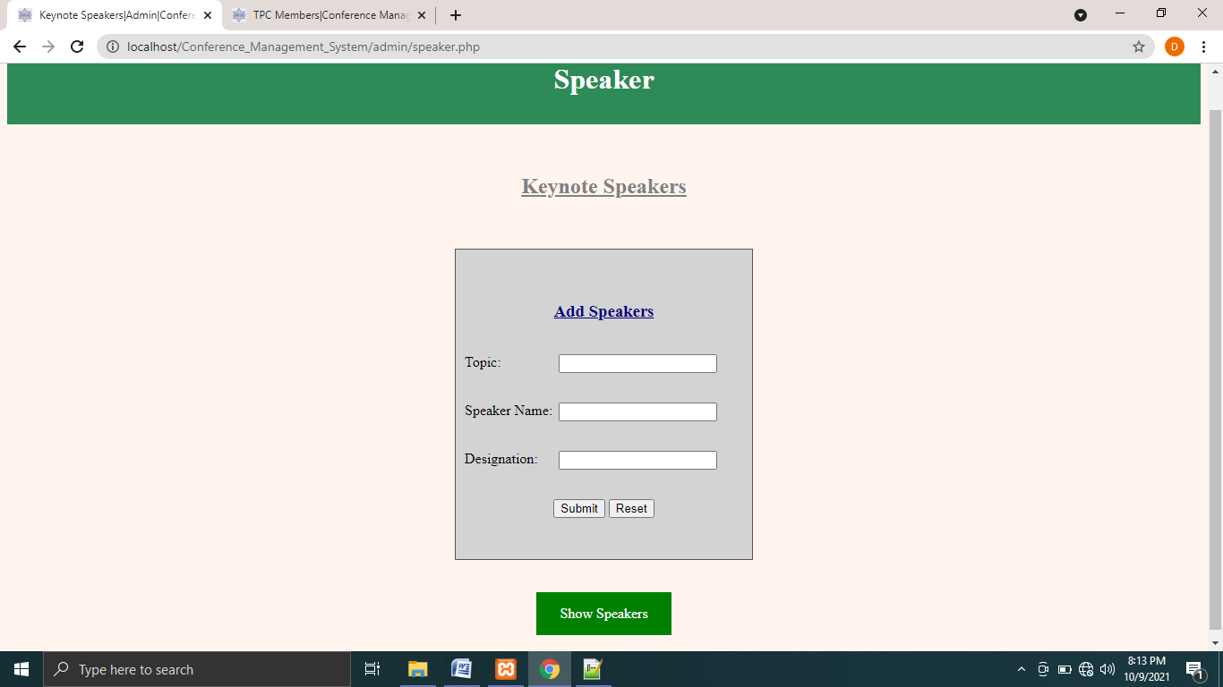

Fig.4.8.5: Admin can speakers’ name, topic and designation

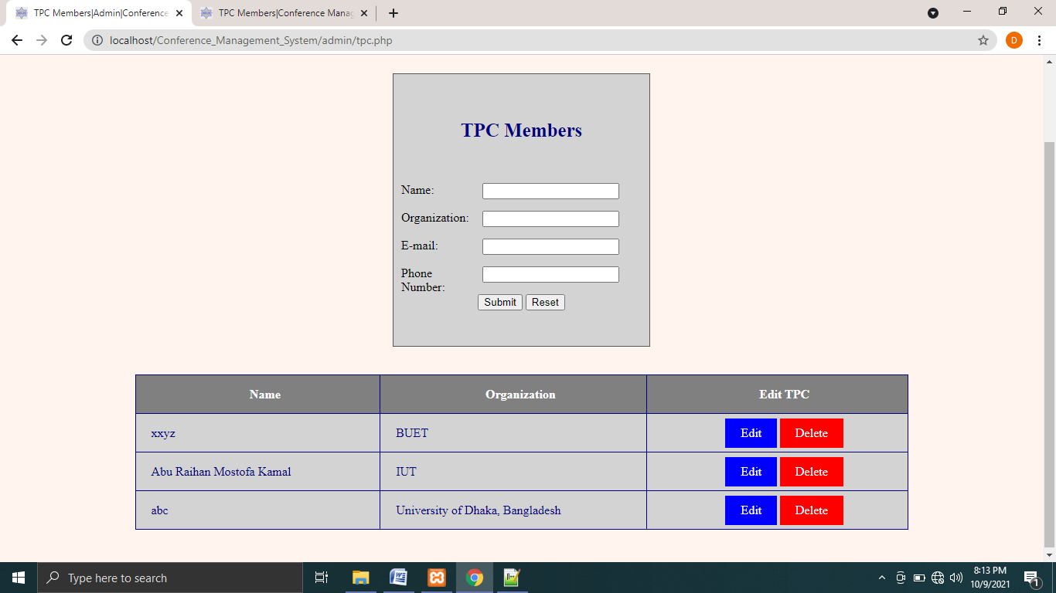

Fig.4.8.6: Admin can add TPC Members

Admin also can add publications information for the conference. They can also add details of the conference and submission guidelines. They can add sponsors and their logo. They also can edit or delete what they added.

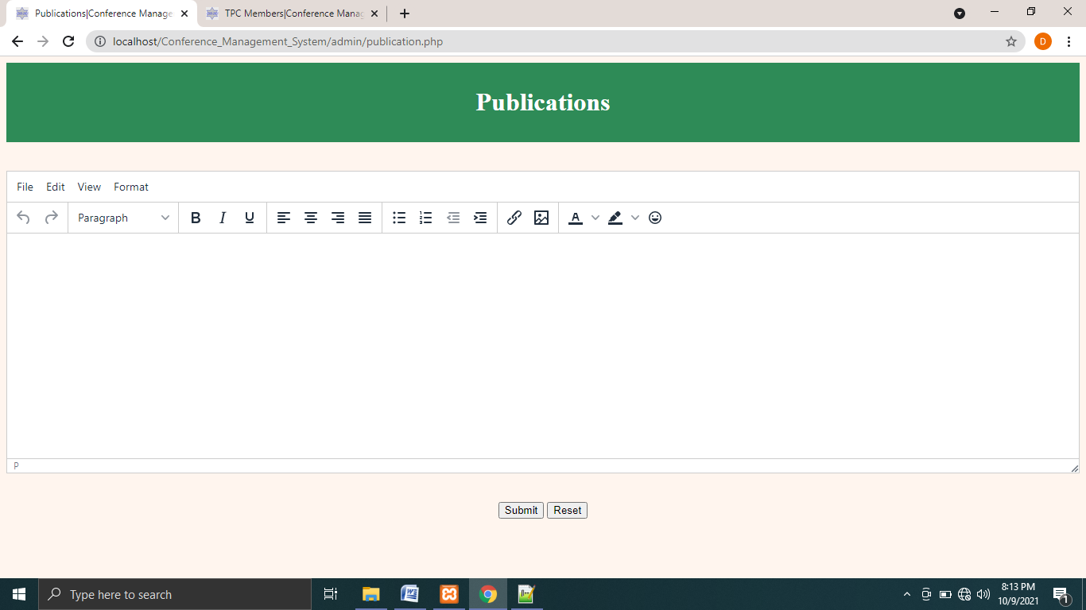

Fig.4.8.7: Publications detail add page

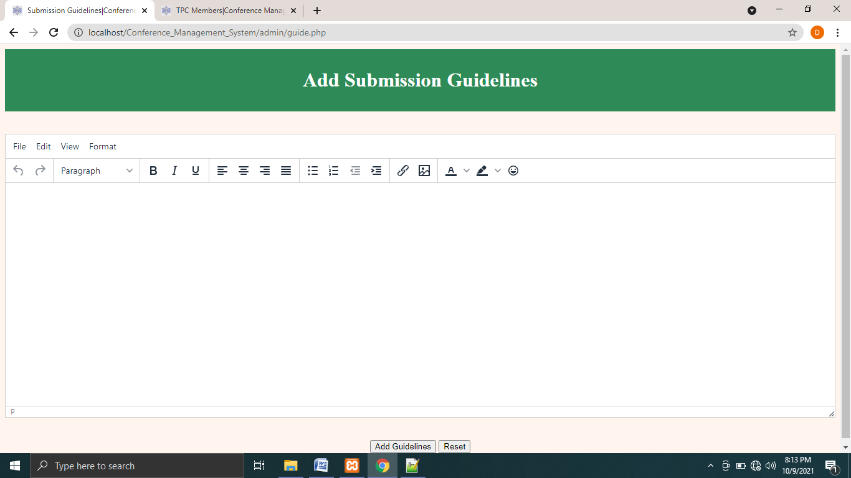

Fig.4.8.8: Submission guidelines addition page

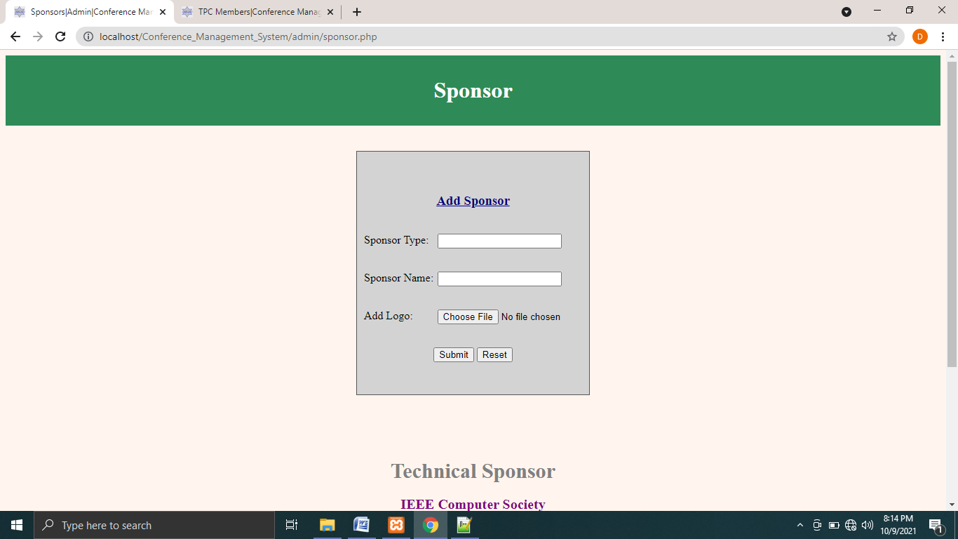

Fig.4.8.9: Sponsors addition page

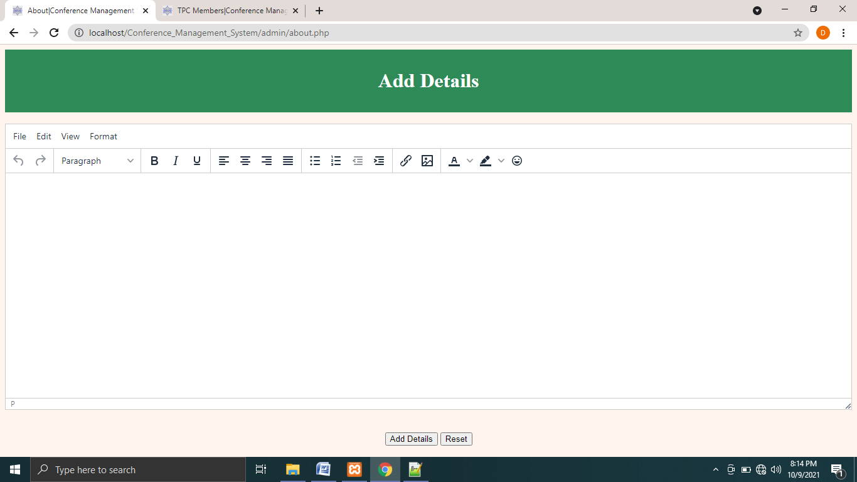

Fig.4.8.10: Details about the conference addition page

Admin can add keynote and technical sessions.

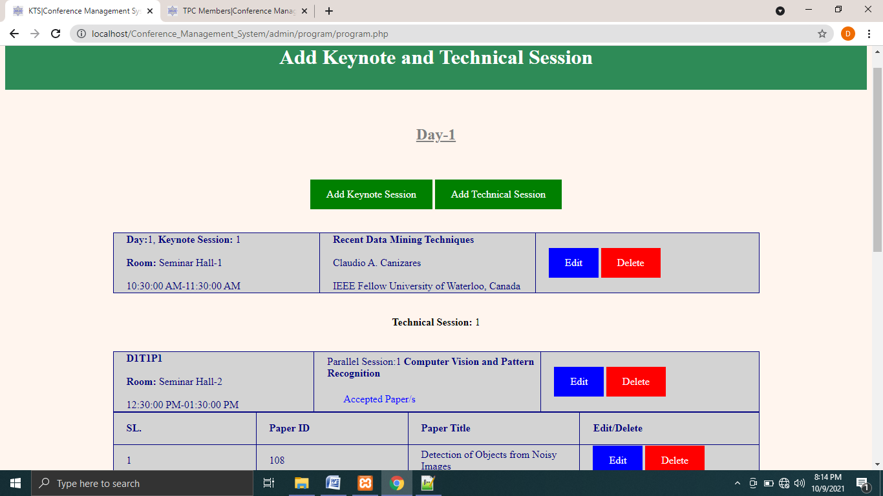

Fig.4.8.11: Keynote and technical sessions addition page

|  |  |
| --- | --- |
|  | Chapter 5 ☑**Conclusion** |

|  |  |
| --- | --- |
|  | ☑Topics   * 5.1 Future Direction * 5.2 Discussion |

**5.1 Future Direction**

As part of this project, we have discussed our progress so far. In future we will do the following:

1. We shall add more functionality to admin as he/she can manage conference more effectively.
2. We shall add paper review process in this system
3. We shall develop an option to give a feedback to the author of the paper.
4. We will try to develop a notification system for the user so he/she can get notified when he/she gets a feedback for the paper.

**5.2 Discussion**

A large number of conferences are being held nowadays. It is really difficult to manage them manually. So, we designed a system that can manage conferences efficiently. In this project we are developing a system where users can create conferences, submit papers, and receive a feedback for their papers.

Although there was some shortfall in this project, there was level best trying to do something new and to do something good. We can expect that this system can do every aspect that is necessary for a conference.

# References

1. Conference. In Wikipedia, Retrieved December 4,2020, from <https://en.wikipedia.org/wiki/Conference>.
2. What is a conference? In eVenues, Retrieved December 4,2020, from <https://evenues.com/event-planning-guide/what-is-a-conference>.